Simple Calculator – TypeScript Code

1. Basic appending of numbers alone:
type Operator = "+" | "-" | "*" | "/";
class Calculator {
private currentInput:
private previousInput: string = "";
private operator: Operator | null = null;
public appendNumber(num: string): void {
if (this.currentInput === "0") {
this.currentInput = num;
}
else {
this.currentInput += num;
}
this.updateDisplay();
}
private updateDisplay(): void {
const display = document.getElementById("display") as
HTMLInputElement;
display.value = this.currentInput;
}
}
const calculator = new Calculator();
document .getElementById("buttons")! .addEventListener("click", (event) => {
const target = event.target as HTMLElement;
if (target.classList.contains("number")) {
calculator.appendNumber(target.innerText);
}
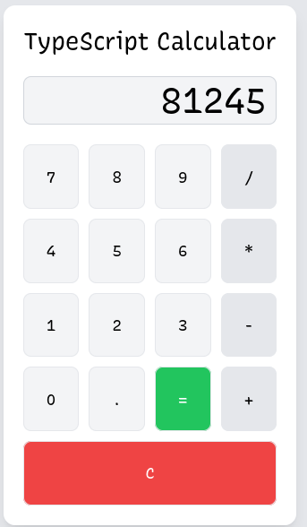
});

2. Clearing the input field: Add the function in Calculator class

public clear():void{
this.currentInput=”0”;
this.updateDisplay();
}

const calculator = new Calculator();
document.getElementById("buttons")!.addEventListener("click", (event) => { const target = event.target as HTMLElement;
if (target.classList.contains("number"))
calculator.appendNumber(target.innerText);
else if(target.classList.contains("clear")){
calculator.clear();
})

3. Accepting operator inputs:

Add the function in Calculator Class
public chooseOperator(op: Operator): void {
if (this.currentInput === "")
return;
this.operator = op;
this.previousInput = this.currentInput;
this.currentInput = "0";
this.updateDisplay();
}

const calculator = new Calculator();
document.getElementById("buttons")!.addEventListener("click", (event) => { const target = event.target as HTMLElement;
if (target.classList.contains("number"))
calculator.appendNumber(target.innerText);
else if(target.classList.contains("clear"))
calculator.clear();
else if (target.classList.contains("operator"))
calculator.chooseOperator(target.innerText as Operator); });

4. Computation
Add the function in Calculator class
public compute(): void {
const prev = parseFloat(this.previousInput);
const curr = parseFloat(this.currentInput);
let result: number = 0;
if (this.operator === "+") result = prev + curr;
else if (this.operator === "-") result = prev - curr;
else if (this.operator === "*") result = prev * curr;
else if (this.operator === "/") result = prev / curr;
this.currentInput = String(result);
this.previousInput = "";
this.operator = null;
this.updateDisplay();
}

const calculator = new Calculator();
document.getElementById("buttons")!.addEventListener("click", (event) => {
const target = event.target as HTMLElement;
if (target.classList.contains("number"))
calculator.appendNumber(target.innerText);
else if(target.classList.contains("clear"))
calculator.clear();
else if(target.classList.contains("operator"))
calculator.chooseOperator(target.innerText as Operator);
else if(target.classList.contains("equals"))
calculator.compute(); });

